Marisa Gittins
Graffiti in Stages
(Memoir)
When I think about all the millions of images that my eyes see every day I am impressed by their uniqueness and beauty. Images can communicate more than words across many different cultures. Seeing an image and forming an opinion does not require a knowledge of the artist’s language. The following quote is by Jonathan Swift, “Vision is the art of seeing the invisible.” Swift was an essayist originally from Dublin, Ireland who lived from 1667-1745. To me the invisible part of an image could be seeing into the artist’s feelings. There are many different kinds of artists and art forms available as a means of expression. To some graffiti is art and history within a community. To others it appears worthless and an act of vandalism. We belong to an ever-changing and progressing society with a wide variety of different people and ideas. Are we ready as a society to accept graffiti as an art form?
Graffiti is mostly recognized today as markings on private or public property, usually considered vandalism. I believe that there is more to graffiti than vandalism. There is a specific message being communicated by the artist. Vandalism is usually done by the younger generation by influences within the society. They usually get in trouble for “tagging” or writing words on walls. Below is an example of “tagging.”
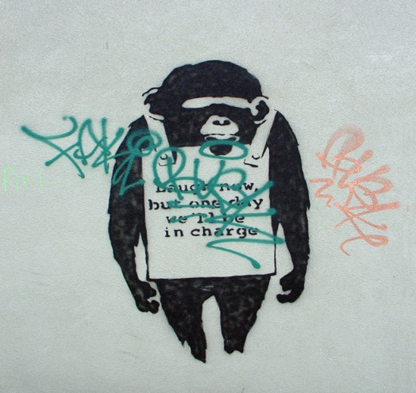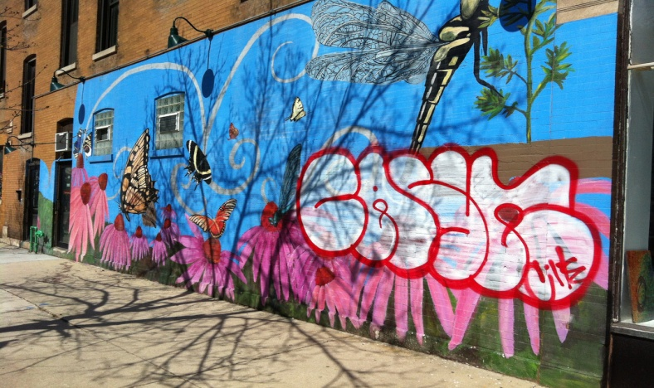
Images courtesy of © GraffitiActionHero.org All Rights Reserved.
Chances are that I am not alone when indicating my exposure to graffiti in my community. In small ways or big ways graffiti can be seen as some sort of statement. Throughout my life I have seen different words/pictures on various public property such as the sides of buildings; sidewalks, signs, etc.
When I was a child my family lived in West Valley. We lived on a corner lot with the back of our house facing a busy intersection. There was a large brick retaining wall around our property. One night the wall was covered with graffiti. Around 10am on a Saturday morning (just a few days after the incident.) My dad and his friend set out to remove the graffiti using a product called “Graffiti Off”. Their intentions were to clean up their property and city property. They ended up being tackled to the ground by two undercover police officers, only based off of suspicion with their involvement in the act. The officers were intending to take my dad and his friend into custody for a misunderstanding. The officers were at a loss with the battle that they were fighting against graffiti. They had probably spent many hours searching for a suspect that they jumped on a tiny glimmer of hope when they witnessed someone near the graffiti.
My dad told me years later how terrified he was of the possibility of being taken away from his family during this altercation. My dad is a good, law abiding citizen that he does his best to contribute to society. He did not see any harm in his intended actions. He is a good, law abiding citizen that does his best to contribute to society. In the end their voices were heard, and the police understood their intent, so no further action was needed. I do not know who the people were that left the graffiti on our wall. I do not know them or their situation. I did not personally see the images so I don’t know what they were trying to communicate. However I am sure that these said people felt that they had an important message that needed to be shared. Something so important that they were willing to go against the law to get their message communicated. Something so important that the message could no longer be kept private but rather very public for all to see if desired.
More recently, while living in California for a short time I performed the service of removing graffiti. I viewed vivid, colorful images full of life with messages of not only hate but also messages of love. These images were on walkways; fences, building walls, and street benches. There were words indicating the need for acceptance and images of unity. The emotions were so powerful that the viewer could not help but take a moment and think about the story behind the graffiti. I felt at that time that we were in a way covering up someone’s soul with solid color, mundane paint. There was no originality or personality left when we were finished. I felt that at times we were covering up a little bit of history. There was no going back once the process began of painting over the areas. The smell of paint tickling my nose as I was left wondering about the stories associated with the graffiti. I was amazed by the work that was put into some of the pieces. Brilliant colors and attention to detail was found in most of the work. There were some areas that the graffiti seemed pointless and did not benefit those directly in the area. Those areas weren’t as heart wrenching to witness during my efforts.
Personally I have had some discovery as to my feelings of graffiti. I have always been exposed to it, in some form or another. My earliest memories were that of the graffiti being placed on my family’s brick retaining wall. At that time I felt that graffiti was more of vandalism. Later in my life I was actually hands on removing the graffiti I was able to have a closer look at the beauty and uniqueness involved. Graffiti can be considered vandalism in some situations just like it can be considered art in other situations. It is difficult to make a blanket statement as to what graffiti is, for every situation. I think that what is known is that graffiti is ever changing and becoming more present in our society.
I think that as a society we are becoming more accepting of differences. I believe that if we are not so quick to cover up someone’s voice we may learn from them. Graffiti can be found as art or vandalism within the community. If we were to accept graffiti as an art form I believe that there will be more voices heard and greater unity amongst the community. Graffiti is a form of expressing ideas and emotions for the general public.

